PRACTICUM REPORT 11TH WEEK COMPUTER NETWORKING
Transfer File Between Two Devices Using FTP


Lecturer:
Dimas Novian Aditia Syahputra, S. Tr. T., M. Tr. T.
Prepared by:
Name: Aisyah Currents
NIM (Student id): 25091397108
Class: International

UNIVERSITAS NEGERI SURABAYA
FACULTY OF VOCATION
INFORMATICS MANAGEMENT STUDY PROGRAM
YEAR 2025

TABLE OF CONTENTS

TABLE OF CONTENTS 1
CHAPTER I 2
INTRODUCTION 2
1.1. Background 2
1.2. Objective 2
CHAPTER II 3
THEORETICAL BASIS 3
2.1. File Transfer Protocol 3
2.2. FTP Function on Android Devices 3
2.3. Network Connection in FTP Communication 3
CHAPTER III 4
METHODOLOGY 4
3.1. Tools and Materials 4
3.2. Procedure 4
CLOSING 7
4.1. Conclusion 7

CHAPTER I

INTRODUCTION

Background
In the modern era of digital communication, data transfer between devices is a crucial activity in both personal and professional environments. One of the most common and reliable methods to transfer files over a network is by using the File Transfer Protocol (FTP). FTP allows users to upload, download, and manage files between a client and a server efficiently.
By using FTP, users can share data between two computers connected through a local network (LAN) or the internet. Understanding how FTP works helps students learn about basic networking concepts, client-server communication, and file management through network protocols. This practicum aims to introduce the basic setup and operation of FTP to send files between two devices effectively.

Objective
The objectives of this practicum are:
- To understand the basic concept and function of the File Transfer Protocol (FTP) in file sharing.
- To learn how to use the FTP feature in an Android file manager to send files between two devices.
- To practice connecting an Android device to another device (computer or smartphone) through FTP.

CHAPTER II

THEORETICAL BASIS

2.1. File Transfer Protocol
File Transfer Protocol (FTP) is a standard communication protocol used to transfer files between devices over a network based on the TCP/IP model. FTP allows users to upload, download, delete, and manage files stored on another device. In general, FTP works using two main roles: the server, which provides access to files, and the client, which requests and transfers files. FTP uses port 21 for control connections and can operate within local networks or the internet. The main advantage of FTP is its simplicity and reliability for file exchange between different operating systems.

2.2. FTP Function on Android Devices
On Android devices, FTP functionality is commonly integrated into File Manager applications. This feature allows the smartphone to act as an FTP server, enabling other devices, such as computers or other smartphones connected to the same Wi-Fi network to access files stored on the Android device. When the FTP sharing feature is activated, the File Manager generates an FTP address that can be opened in a web browser or FTP client on another device. This provides an easy and wireless method for transferring files without using cables or third-party apps.

2.3. Network Connection in FTP Communication
For the FTP process to work properly, both devices involved must be connected to the same local network, such as a Wi-Fi connection. The network assigns each device a unique IP address, which is used to identify and communicate between them. When the FTP server is activated on one device, and the other connects using the provided IP address, a communication channel is established for file transfer. Stable and secure network connections ensure the file transfer runs smoothly and efficiently.

CHAPTER III

METHODOLOGY

3.1. Tools and Materials
The tools and materials used include:
- Android Smartphone
Used as the FTP server or client.
- Laptop
Used to access the FTP server and transfer files.
- Wi-Fi Network
Both devices must be connected to the same Wi-Fi network to enable FTP communication.
- File Manager Application with FTP Feature
For example: Files by Google, CX File Explorer, or Mi File Manager. These apps allow enabling FTP server mode on Android.
- File Explorer
Used on the second device (laptop/smartphone) to access the FTP address and transfer files.

3.2. Procedure
The following steps explain the process of setting up an FTP connection using an Android device as the FTP server and another device (laptop or smartphone) as the client. This procedure includes preparation, activation of the FTP server, connection setup, file transfer, and closing the connection after use.
- Make sure both devices (Android and laptop/another phone) are connected to the same Wi-Fi network.
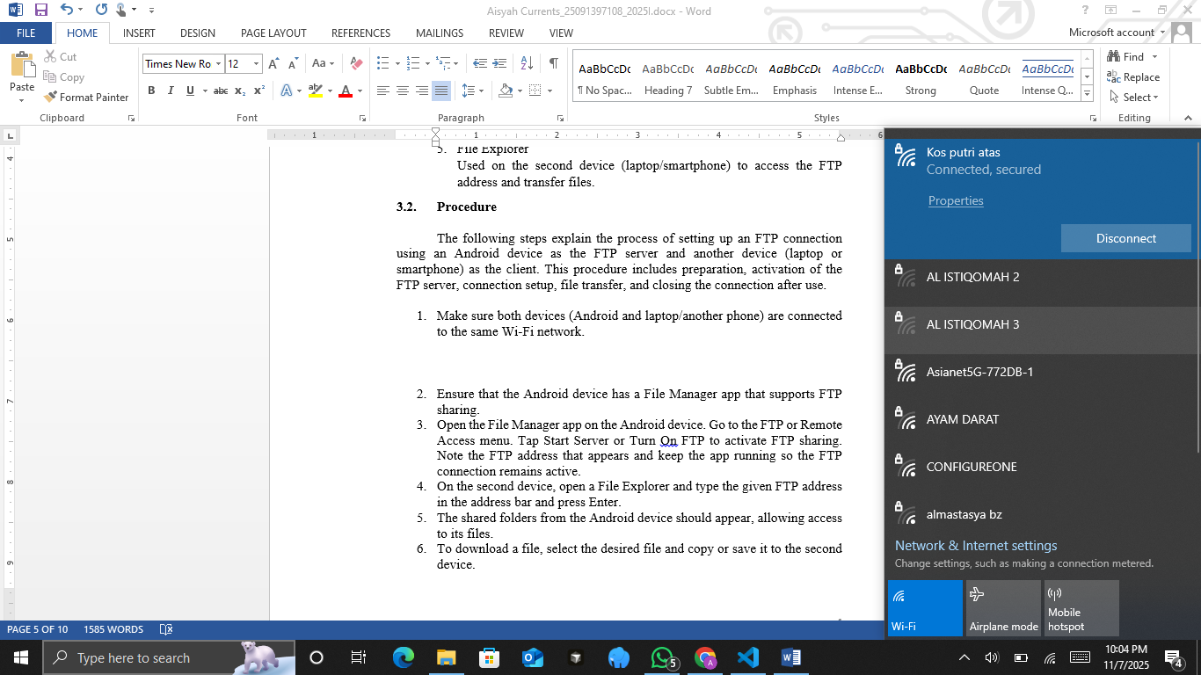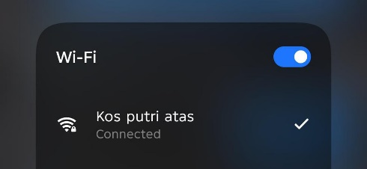
- Open the File Manager app on the Android device. Go to the FTP or Remote Access menu. Tap Start Server or Turn On FTP to activate FTP sharing. Note the FTP address that appears and keep the app running so the FTP connection remains active.
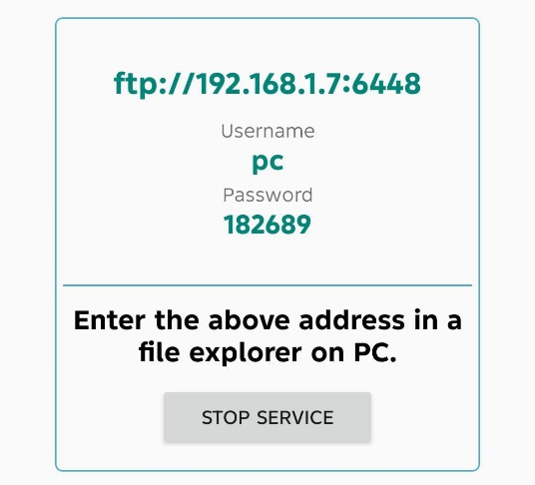
- On the second device, open a File Explorer and type the given FTP address in the address bar and press Enter.
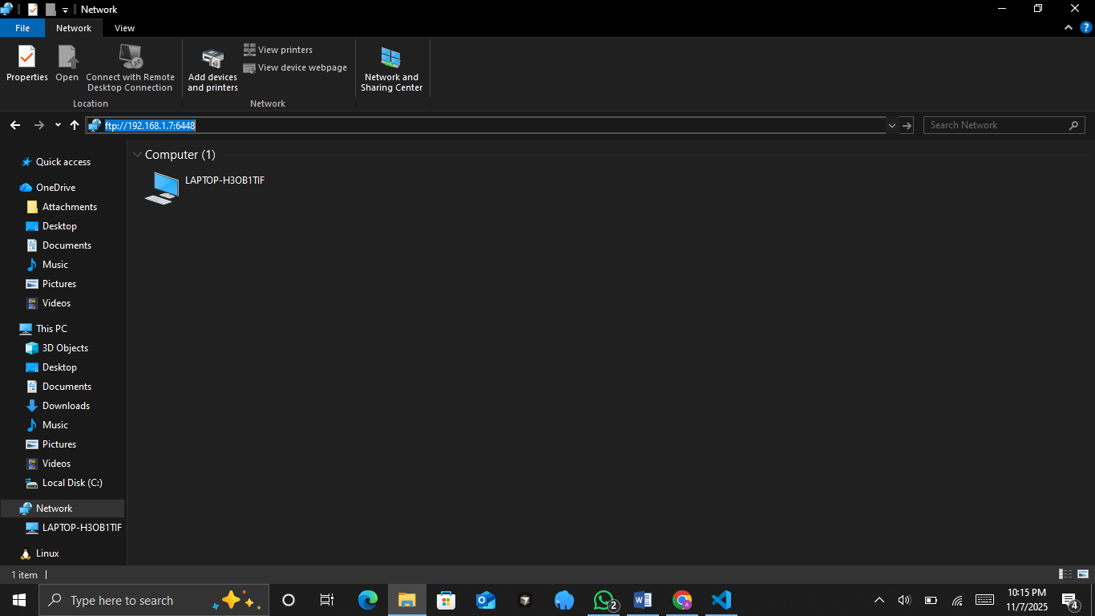
- The shared folders from the Android device should appear, allowing access to its files.
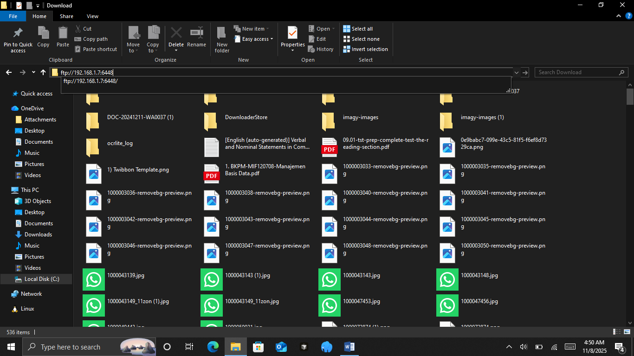
- To download a file, select the desired file and copy or save it to the second device.
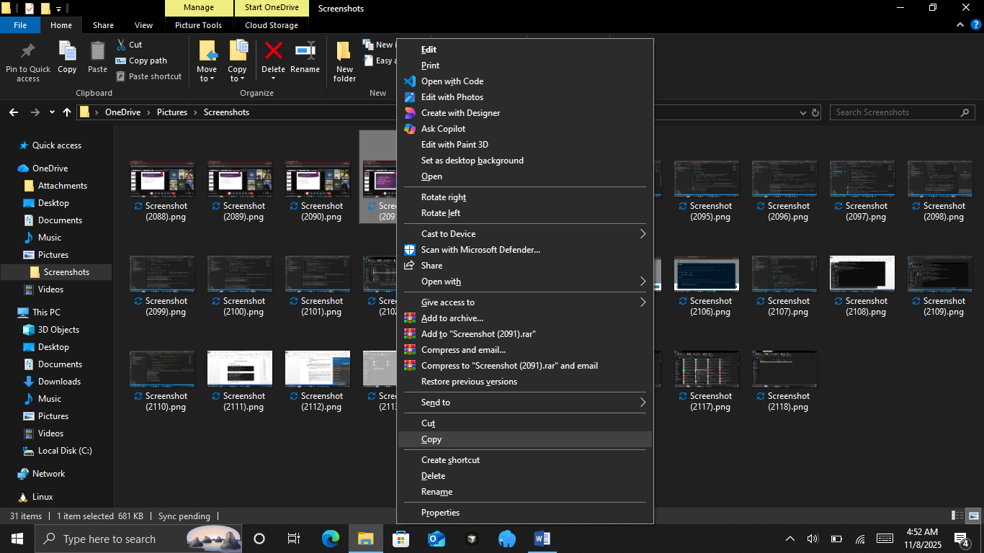
- To upload a file, drag or copy the file into the FTP folder and verify that the file has been successfully transferred by checking its presence and integrity on both devices.
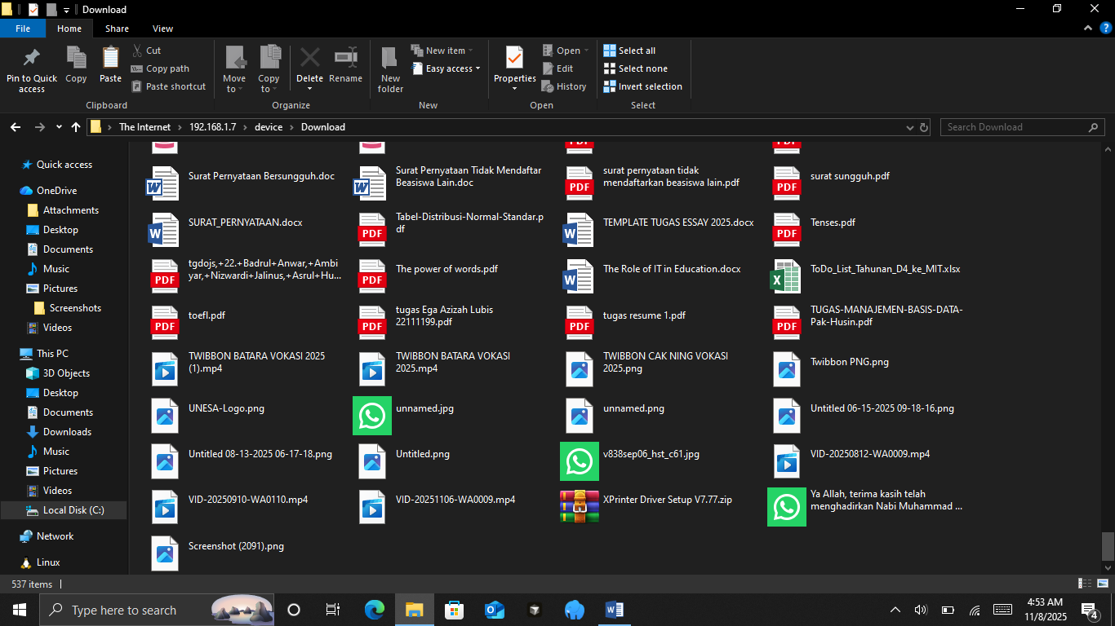
- Once the file transfer is complete, return to the Android device’s File Manager. Tap Stop Server or Turn Off FTP to close the FTP connection and ensure all files are safely stored on both devices.
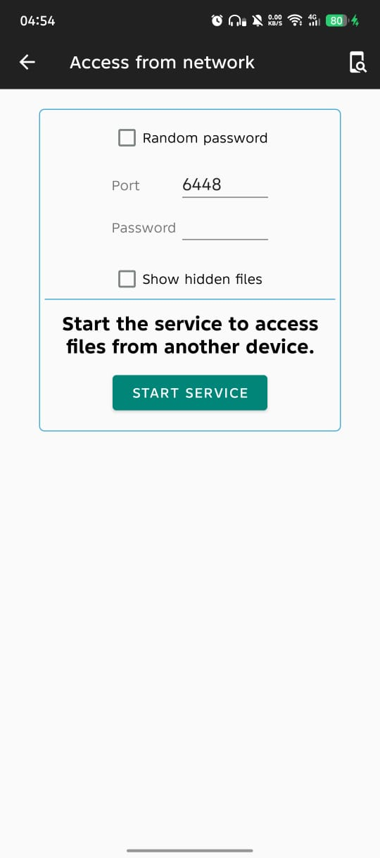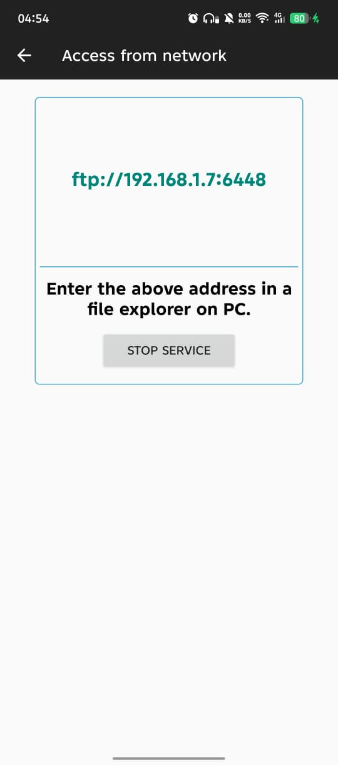

CHAPTER IV

CLOSING

4.1. Conclusion
The practicum, the FTP feature on the Android device was successfully activated using the File Manager application. After starting the FTP server, the application displayed an FTP address such as ftp://192.168.1.7:6448. This address was entered into the web browser on a laptop connected to the same Wi-Fi network.
The laptop was able to access the shared folders on the Android device and download files from it. File transfer was successful without connection errors. The transferred files were verified to be identical to the originals, confirming that the FTP connection worked correctly.

